**Smart Soil Moisture Monitoring System**

**Introduction:**

The Embedded IoT-based Smart Soil Moisture Monitoring System is a project aimed at automating plant care through real-time monitoring of environmental and soil conditions. This system seeks to enhance farming productivity and decrease manual work by ensuring that plants are given sufficient water according to real soil moisture conditions. It is especially beneficial for home gardening, greenhouse management, and small-scale agricultural uses.   
  
At the heart of this project is the ESP32-WROOM-32 microcontroller, offering processing capabilities and wireless communication. A soil moisture sensor measures the amount of water in the soil, whereas a DHT11 sensor tracks the surrounding temperature and humidity. When the ground gets too arid, the system automatically triggers a small water pump to water the plant. Visual information is displayed on a 0.96" OLED screen that presents real-time sensor data. Moreover, an LED and a buzzer serve to offer visual and auditory notifications for low moisture levels or system operations.   
  
By combining these elements, the system delivers an effective, immediate solution for intelligent irrigation, assisting in water conservation and encouraging healthier plant development. This project showcases the real-world use of embedded systems and IoT in precision agriculture

**Block diagram:**

Power supply

Water pump

ESP 32

LED Status indicator

Buzzer Alert system

OLED display

WiFi +

Bluetooth

Module

Thingsboard App

Humidity sensor

Moisture sensor

**Flowchart**

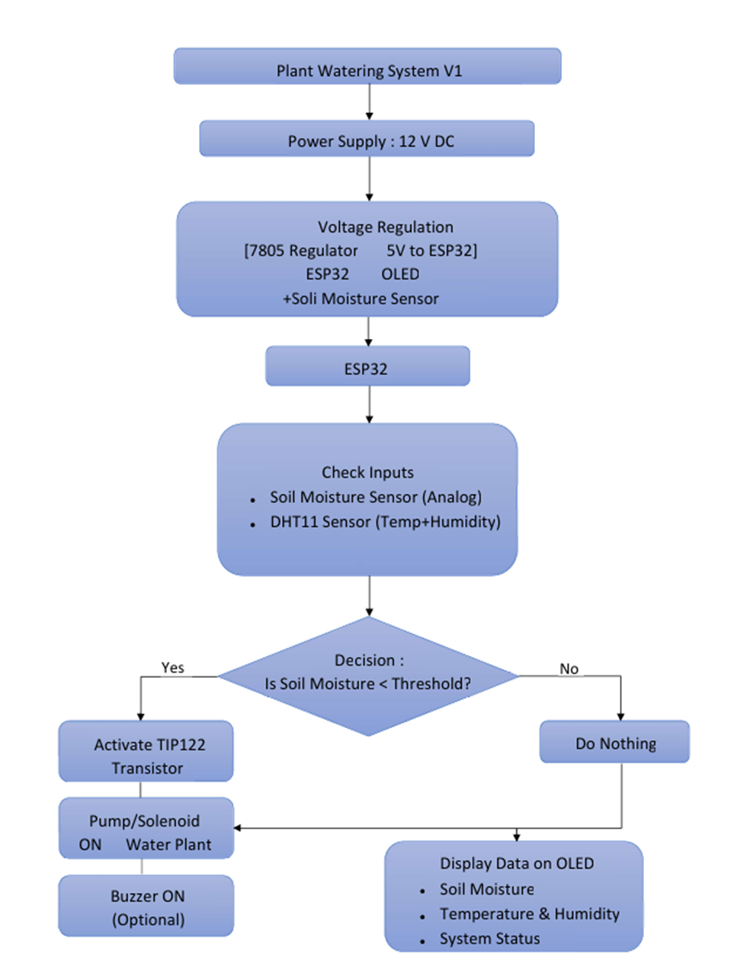

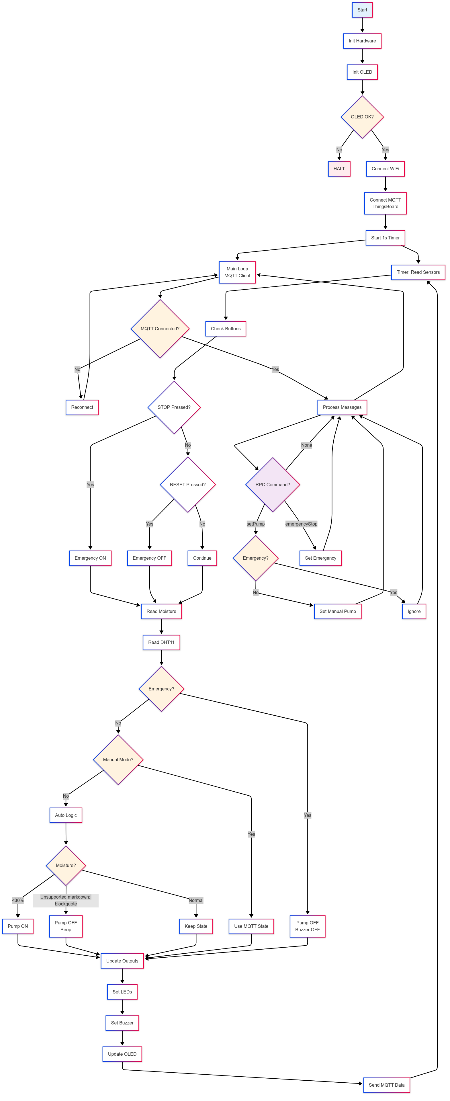**Flowchart**



**Results**

**System Overview and Behavior**

The Smart Soil Moisture Monitoring System was assembled and tested using the ESP32-WROOM-32 microcontroller. It successfully collected data from the DHT11 sensor (temperature and humidity) and the soil moisture sensor. Real-time values were displayed on the 0.96" OLED screen. When the soil was dry, the system automatically activated the mini water pump, confirming that the moisture threshold logic worked as intended. The LED and buzzer also functioned correctly, providing visual and auditory alerts.

**Test Case 1: Dry Soil Condition**

* **Initial Conditions:**
  + Soil moisture: below threshold (dry)
  + Temperature: 30°C
  + Humidity: 45%
* **System Response:**
  + OLED showed live readings
  + Pump activated automatically
  + LED turned ON
  + Buzzer buzzed briefly
* **Result:** All components responded correctly to the dry condition.

**Test Case 2: Moist Soil Condition**

* **Initial Conditions:**
  + Soil moisture: above threshold (wet)
  + Temperature: 29°C
  + Humidity: 50%
* **System Response:**
  + OLED updated values
  + Pump remained OFF
  + LED remained OFF
  + No buzzer sound
* **Result:** The system conserved water and correctly identified no need for irrigation.

**Test Case 3: Continuous Monitoring**

* **Setup:** System left running for 3 hours in a plant pot.
* **Observed Behavior:**
  + Periodic updates on OLED
  + Pump triggered 3 times based on soil dryness
  + Data sent to ThingsBoard (if configured)
* **Result:** Demonstrated long-term monitoring and autonomous decision-making.

**Display Output**

* The OLED clearly displayed:
  + "Soil Moisture: XX%"
  + "Temp: XX°C | Humidity: XX%"
  + "Status: Pump ON/OFF"
* Display was readable under indoor lighting and updated every few seconds.

**Reliability & Responsiveness**

* **System Delay:** <1 second between detection and actuation
* **Wi-Fi Connectivity:** Stable with minimal lag
* **Power Supply:** 5V via USB or regulated adapter; system ran continuously without failure.

**Conclusion**

The Smart Soil Moisture Monitoring System effectively accomplished its objective of automating irrigation according to current environmental conditions. The system integrated essential sensors and actuators with the ESP32-WROOM-32, allowing it to accurately detect soil moisture, monitor temperature and humidity, and activate the mini water pump as needed to respond appropriately.   
  
The incorporation of a 0.96" OLED display enhanced system engagement, enabling users to access live data easily. The addition of an LED and buzzer enhanced reliability with visual and audio notifications. Throughout the testing phase, the system reliably reacted to varying soil conditions and showcased the effectiveness of integrated IoT in precision farming.   
  
In summary, this project emphasizes that cost-effective parts and basic logic can produce an effective and expandable smart agriculture system. It encourages water-saving practices, decreases physical work, and establishes the groundwork for more sophisticated IoT-driven farming systems. Upcoming enhancements might feature a mobile app interface, automated scheduling, or solar-powered functionality to improve system sustainability and user-friendliness.